**Group Members:**

1. Bilal Ahmed Khan (20k-0183)
2. Syed Mohsin Ahmed (20k-0124)
3. Mohammad Kamran (20k-0269)

**Project Objective:**

To develop a smart lighting system which turns on the lights in a room when it detects the presence of human beings and turns off the lights when there is no one present. Hence, saving electricity.

**Components used:**

1. PIR sensor
2. Transistors
3. Resistors
4. Arduino board
5. 5V Power supply
6. Wires
7. Light Bulb

**Abstract:**

The core idea behind the project is to save electricity by efficiently turning off the lights in the room when there is nobody present. For this purpose, we will use a PIR sensor which will detect the presence of any living being in its vicinity and turn on the lights in the room. The lights will automatically turn off when the subject leaves the room i.e., goes out of the range of the sensor. Implementation of this system in the commercial sector (where electricity costs are significantly higher) may save significant amounts of energy.

**Concept Circuit Diagram:**

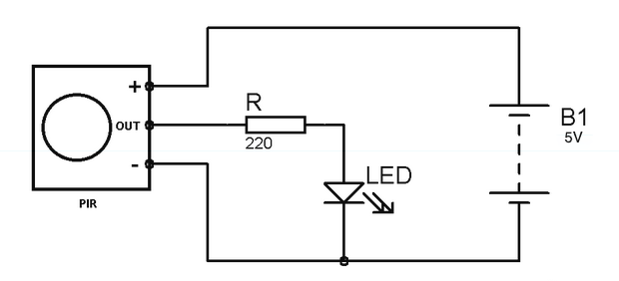**P.S.** This diagram only depicts the core concept whereas the actual project will have a number of LEDs connected to the sensor in order to cover a large area such as a corridor or a hall etc.